PRESS RELEASE

### 

# VS Code Gets Its First XAML UI Designer with OpenSilver 3.1

***Open-source framework brings visual UI design to the world’s most popular code editor, alongside progress on the “WPF Everywhere” vision, .NET 9 support, and a modern UI theme***

**Paris, France – December 10, 2024** – Userware has announced the release of OpenSilver 3.1, the latest version of its open-source framework for building sophisticated .NET web applications. This update introduces the first drag-and-drop XAML designer for Visual Studio Code, allowing developers to visually build user interfaces in one of the world’s most popular code editors. Additionally, OpenSilver 3.1 introduces a modern UI theme, expands WPF support for web-based applications, and delivers full compatibility with .NET 9.

### **Drag-and-Drop UI Designer For VS Code**

A highlight of OpenSilver 3.1 is its new drag-and-drop XAML designer for VS Code. Previously limited to Visual Studio on Windows, the designer now works seamlessly on macOS and Linux, enabling cross-platform visual UI development.

“This release makes OpenSilver the first framework to bring a drag-and-drop UI designer to VS Code,” said Giovanni Albani, CEO of Userware. “Our goal is to simplify and streamline the development experience for .NET developers, whether they’re modernizing existing applications or building new ones.”

The designer supports over 100 ready-to-use controls, such as data grids and charts, and features an AI assistant for generating UI layouts from text prompts. Developers can try it online at [https://XAML.io](https://xaml.io)

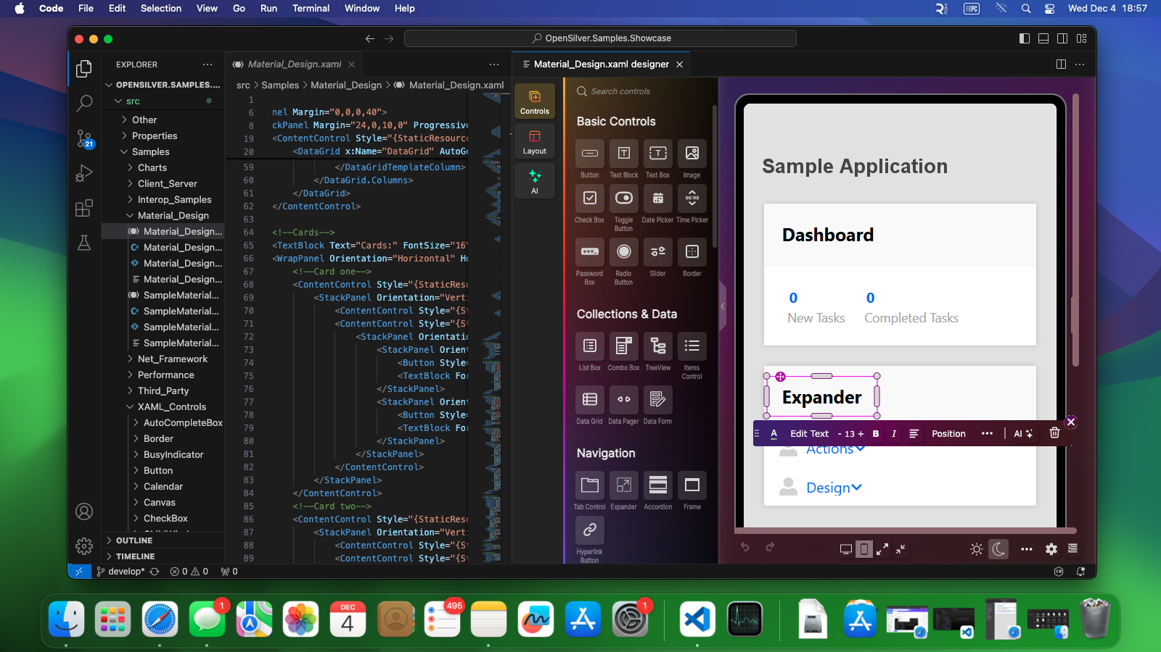***The new XAML UI designer in VS Code on macOS***

### **Progress on the “WPF Everywhere” Vision**

OpenSilver 3.1 advances its mission to bring the robust features of WPF to the web. New support for features like DynamicResource, MultiBinding, x:Static, and UniformGrid further enables developers to create sophisticated web applications using familiar tools and frameworks.

“WPF is a gold standard for scalable, feature-rich applications,” said Albani. “With OpenSilver, we’re removing the barriers that have kept WPF tied to the desktop, giving developers the ability to create modern web applications with the same tools and functionality.”

While full WPF compatibility is still a work in progress, OpenSilver plans to deliver advanced WPF support by mid-2025.

### **A New Modern UI Theme**

Inspired by Material and Fluent Design, the new modern UI theme provides a contemporary aesthetic with built-in light and dark modes. Developers can easily customize color palettes within the designer, simplifying branding and theming.

For legacy applications, the original Silverlight theme remains available, ensuring pixel-perfect migrations while offering the flexibility to refresh visuals when desired.

**Staying Current with .NET 9**

OpenSilver 3.1 is fully compatible with .NET 9, offering developers faster app startup times, enhanced debugging tools, and improved runtime performance. The framework uses WebAssembly and HTML5, ensuring that applications run natively in modern browsers without requiring plugins or installations.

This release also resolves a previous long-standing issue for developers: misleading XAML errors during design time. OpenSilver 3.1 now delivers a more intuitive and reliable design time experience.

**Looking Ahead**

Future updates to OpenSilver will focus on full WPF compatibility, integration with MAUI Hybrid for cross-platform development, Blazor interoperability, and new features like 3D user interfaces.

“We are committed to supporting the .NET ecosystem by offering tools that help developers build modern web apps and modernize legacy ones efficiently,” said Albani. “OpenSilver bridges legacy and greenfield development, equipping businesses with a forward-looking framework.”

**Availability**

To try the drag-and-drop XAML designer, visit [https://XAML.io](https://xaml.io)

OpenSilver 3.1 is now available as a free and open-source framework. Developers can get started at <https://opensilver.net>

For a detailed list of changes and screenshots of the new features, read the official blog announcement at <https://opensilver.net/announcements/3-1/>

—

**About OpenSilver**

### 

OpenSilver is a free, open-source platform developed by Userware that brings the power of .NET to the web. It enables developers to create rich, interactive web applications with native-like performance using familiar C# and XAML.

Designed for cross-platform compatibility, OpenSilver applications run on modern browsers (Chrome, Edge, Firefox, Safari…) and operating systems (Windows, macOS, Linux…) without plugins or installations.

Initially created as a replacement for Microsoft Silverlight, OpenSilver now supports a variety of use cases, including migrating legacy applications to the web (Silverlight, WPF, LightSwitch, VB), building new modern line-of-business applications, and empowering C#, VB.NET and F# developers with intuitive design tools to create visually engaging, data-driven web applications.

For more information, visit <https://opensilver.net>

—

### **About Userware**



Founded in 2007, Userware develops innovative solutions to help businesses modernize and embrace emerging technologies. Its .NET division specializes in migrating legacy Silverlight, WPF, LightSwitch, and VB.NET applications to the modern web. It also provides tools like OpenSilver, [XAML.io](https://xaml.io), and [XRSharp.io](https://xrsharp.io) to build powerful, cross-platform applications.

Userware XR Studios delivers immersive VR/AR experiences and 3D web solutions, such as those seen at <https://www.youtube.com/@userwaredev>

Userware AI Labs helps businesses integrate AI into their products, such as adding AI-assisted features to the UI designer at XAML.io, while staying ahead of industry trends with initiatives like [UseCasesFor.ai](https://usecasesfor.ai), a curated resource of 250+ real-world AI examples.

For more information, visit <https://userware.dev>

—

**Press Contact:**

Vasil Buraliev  
Media Relations at Userware   
Email: vasil.buraliev@userware.dev